DESIGN AND FABRICATION OF

SKID PLATE

**PROJECT REPORT**

**Submitted by:**

1. **N. MOHAMMED BILAL 110119114033**
2. **JOGESHWARE RAO 110119114305**
3. **F. KHAJA EZZAZUDTHEEN AHMED 110119114306**
4. **A.ARSHAD HASAN 110119114701**



**IN PARTIAL FULFILMENT FOR THE AWARD OF THE DEGREE OF**

**BACHELOR OF ENGINEERING**

**IN**

**MECHANICAL ENGINEERING**

AALIM MUHAMMED SALEGH COLLEGE

OF ENGINEERING,AVADI

ANNA UNIVERSITY:CHENNAI-600 025

JUNE 2022

BONAFIDE CERTIFICATE

Certified that the project report “**DESIGN AND FABRICATION OF SKID PLATE ”** is the bonafide work of “**N. MOHAMMED BILAL , JOGESHWARE RAO , F. KHAJA EZZAZUDTHEEN AHAMED , A. ARSHAD HASAN ”**who carried out the project work under my supervision.

**SIGNATURE SIGNATURE**

DR.S.RAMKUMARMr.T.N JAFFER ALI

**HEAD OF THE DEPARTMENT SUPERVISOR**

Professor And Head Of The Department, Assistant Professor,

Department of Mechanical Department of Mechanical

Engineering Engineering

Aalim Muhammad SaleghAalim Muhammad Salegh

College of Enginnering, College of Enginnering ,Avadi-IAFAvadi-IAF

**CERTIFICATE OF EVALUATION**

Certified that this project report **“DESIGN AND FABRICATION OF SKID PLATE ”** is the bonafied work of………………………………………………………………as their Design and Fabrication project work.

**Submitted on : .....................**

**Appeared for the university examination held on :......................**

**INTERNAL EXAMINER EXTERNAL EXAMINER**

**ACKNOWLEDGEMENT**

I am extremely thankful to the management founder late **Dr.S.M.SHAIK NURDDIN** and the secretary and correspondent **Janab.S.SEGU JAMALUDEEN** and the principal **Dr.S.SATHISH**, for providing the necessary infra structural facilities and conductive academic atmosphere to take up this project. I register our deep sense of thanks to **Dr.S.RAMKUMAR** Professor and Head, Department of Mechanical Engineering, Aalim Muhammed Salegh College Of Engineering, Muthapudupet, Avadi IAF, Chennai for extending all the support and facilities of the department. I am extremely grateful to our guide **Mr.T.N JAFFER ALI** Assistant Professor in Department of Mechanical Engineering, for his kindness and valuable guidance that have enabled us to complete this work successfully.We whole-heartedly thank all the members of faculty of the Department of Mechanical Engineering, Aalim Muhammed Salegh College of Engineering, Muthapudupet, Avadi IAF, Chennai-600055. I express genuine gratitude to our throughout parents, and our friends for the moral support and encouragement given our careers. Our sincere thanks to all our well-wishers and friends from whom we received liberal help for making this work a success.

**CONTENTS**

***Chapter No. Title. Page No.***

**ABSTRACT**

01.Introduction 7

02. Description Of Components 8

**0**3. Process 9

04.Autocad 2D Diagram10

05. Different Stages 13-21

06. Working 16

07. Sheet Metal Cutting With Angle Grinder 22

08. Sheet Metal Grinding Process 24

With Angle Grinder

09. Arc Welding 25

10. [1.1] - 4 Types Of Welding 26

[1.2] - Sheet Metal Welding Process With

Arc Welding (MIG) 27

11. Cost Estimation 30

12. Advantages And Disadvantages 31

13. Conclusion 32

**ABSTRACT:**

A skid plate is an abrasion-resistant material affixed to the underside of a vehicle or boat to prevent damage to the underside when contact is made with the ground. Skid plates may be used on [off-road](https://en.m.wikipedia.org/wiki/Off-road) vehicles, motorcycles and [lowered](https://en.m.wikipedia.org/wiki/Lowrider) vehicles to prevent damage to the underside. skid plates are also added to vehicles for an off-road look. Steel skid plate for the protection of the engine and silencer

**INTRODUCTION:**

The idea behind skid plates is simple to understand. These plates work as a protective barrier between your vehicle's base framework and the road underneath. By absorbing the shock of any impact with the road, these skid plates keep your vehicle delicate components safe from being exposed to extensive damage Skid plates are thicker and are made from aluminum or steel. Aluminum skid plates are great when it comes to lightweight materials. They are not as strong as steel and tend to develop holes or rips. Steel skid plates are heavier but stronger than the aluminum. these skid plates act as a protective shield for its undercarriage. This is much like a vehicle which externally covers the engine and its closeby components. But even in this smiliary, there’s a stark difference between a the differen vehicles and its skid plates. A bike offers more cosmetic appeal than a functional use. On the other hand, skid plates serve a very crucial safety need for all types of bikes especially those with a lowered height or off-road usage.

**COMPONENTS:**

* **STAINLESS STEEL SHEET METAL:**

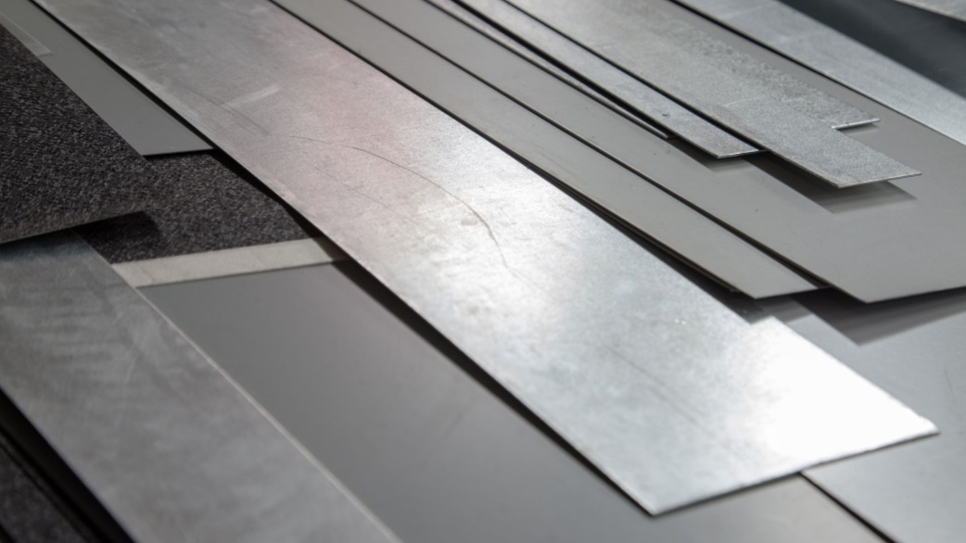

* The sheet metal is used for fabrication work.
* Sheet metal length 127*76 cm
* Thickness 2mm.

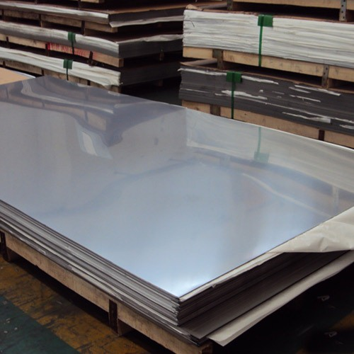

Process:

* First process to buy stainless sheet metal with length of 127*76cm and thickness 2mm.Then cut the one part of the sheet metal into the length with 61.5 cm length 25cm breadth with 2mm thickness.
* Then bend the sheet metal according to the dimensions Skid plate will be completed by some minor process.Then paint or coat the skid plate with fully furnished .

**AUTO CAD 2D DIAGRAM - 1**



**AUTOCAD 2D DIAGRAM -2**



**AUTOCAD 2D DIAGRAM -3**



**FIGURE NO - 1**

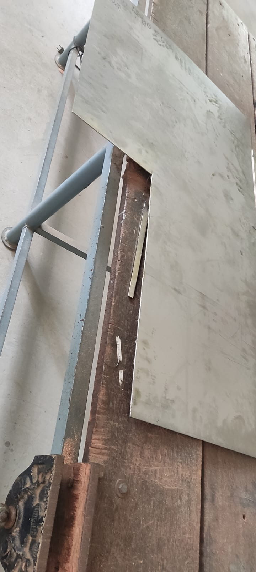

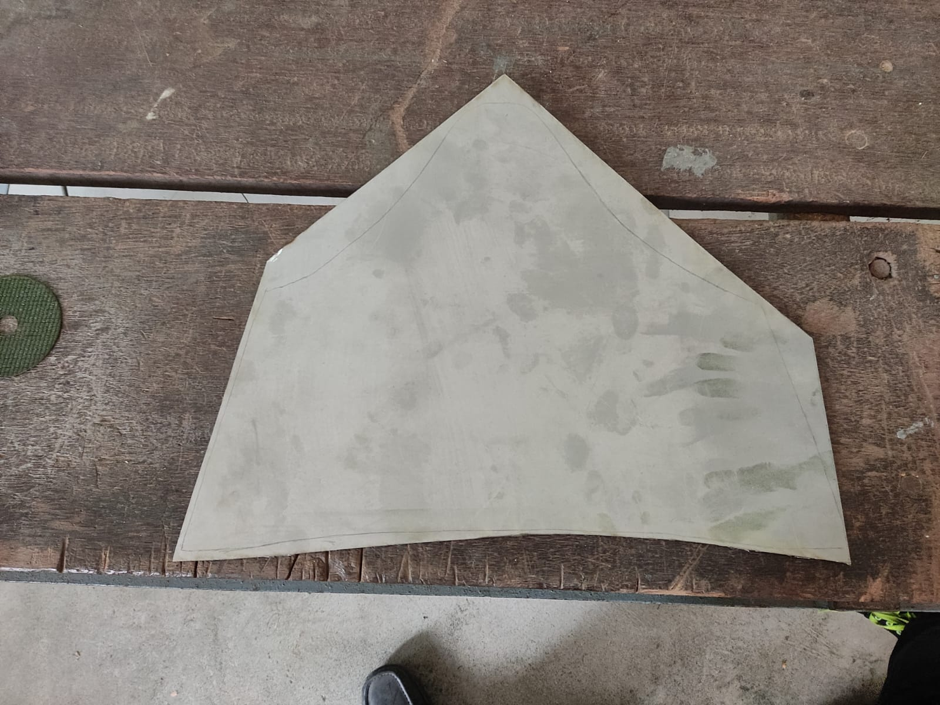

**FIGURE NO - 2**

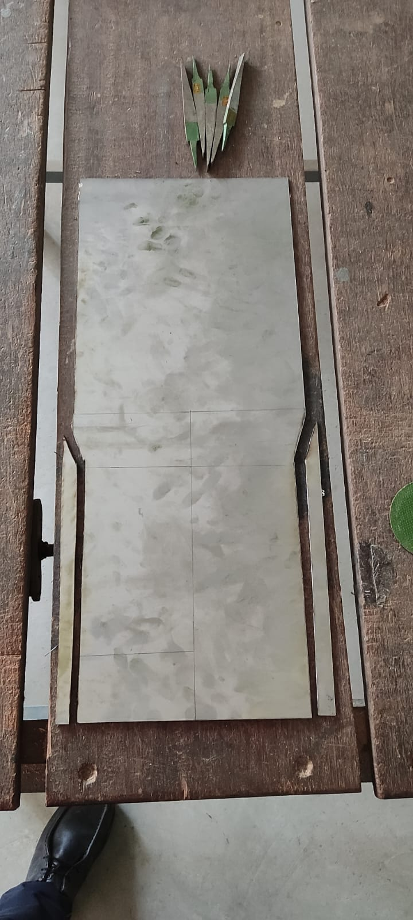

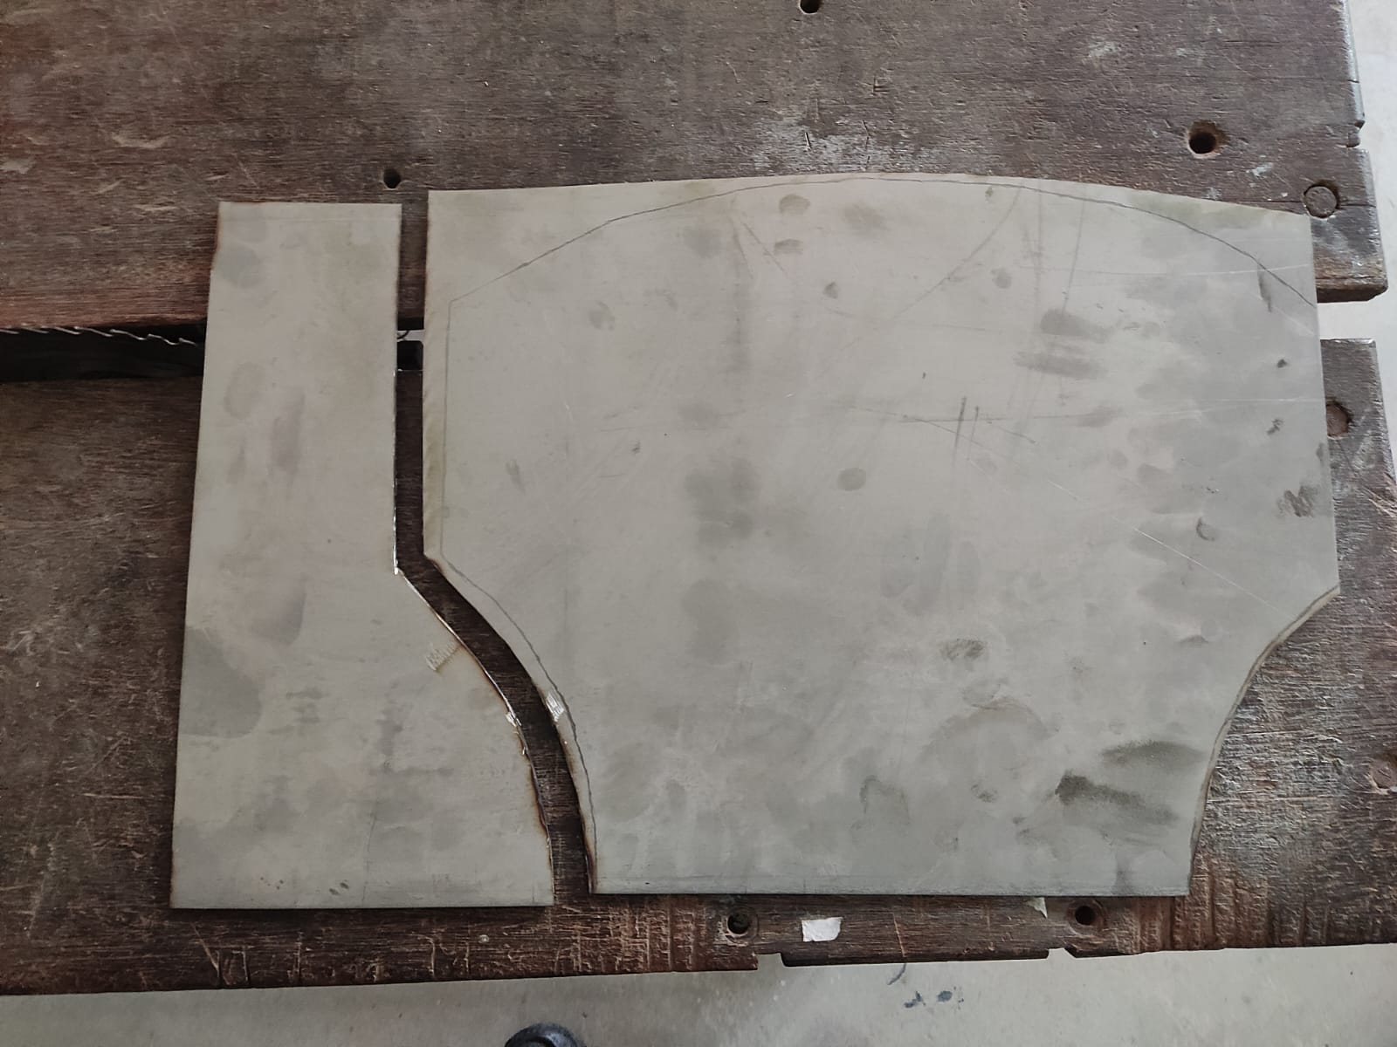

**FIGURE NO - 3**

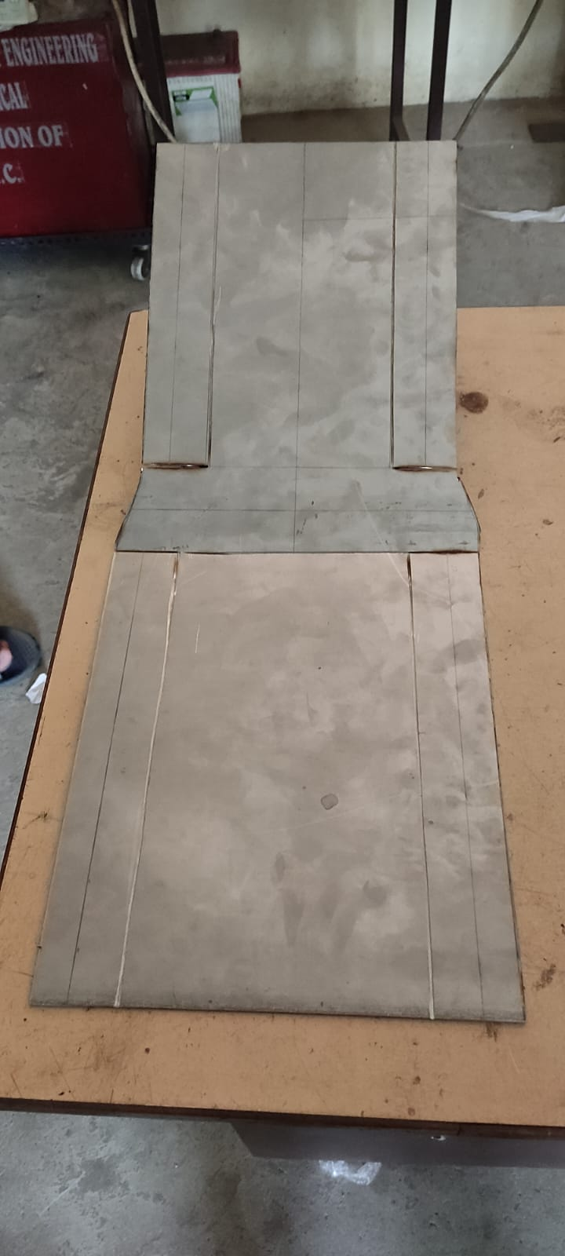

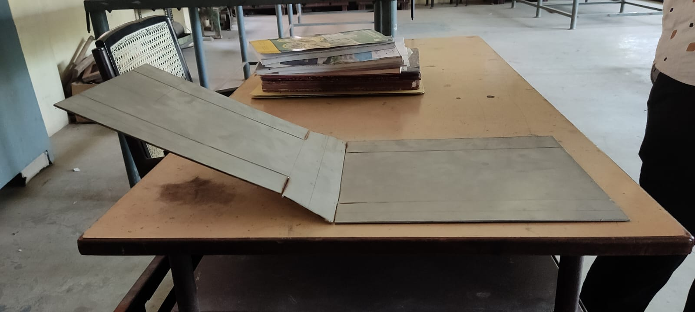

skid plates work:

The idea behind skid plates is simple to understand. These plates work as a protective barrier between your vehicle’s base framework and the road underneath. By absorbing the shock of any impact with the road, these skid plates keep your bikes’ delicate components safe from being exposed to extensive damage. To put it simply, skid plates are to a car’s undercarriage what bumpers are to a vehicle’s front. Both of these components are made to prevent physical damage, absorb excessive force, and protect your vehicle. The difference is that bumpers protect bikes from their very front, while skid plates play this role for the chassis of vehicles. In order to understand how to do skid plates work, it is important to learn how they are made. Skid plates are typically developed from metal. But they can also be created using a variety of plastics. It is also important to remember that metal-based skid plates are more expensive than their plastic-based counterparts, but the former is more durable and provides more value for money in the long run. To put it in simpler words: the stronger the material, the better chance the skid plate has of protecting a bike.

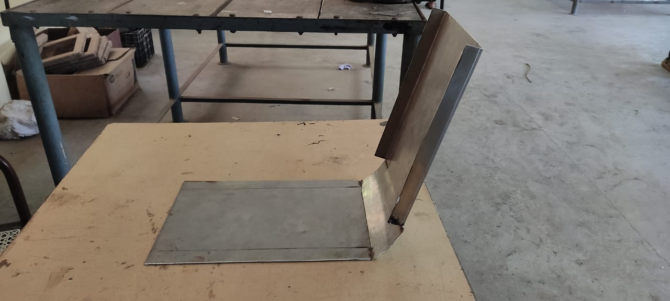

**FIGURE NO – 4**

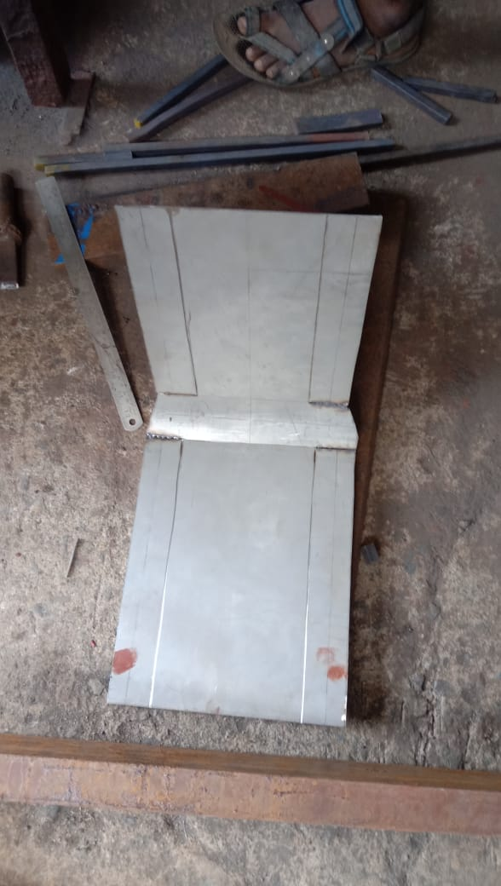

**FIGURE NO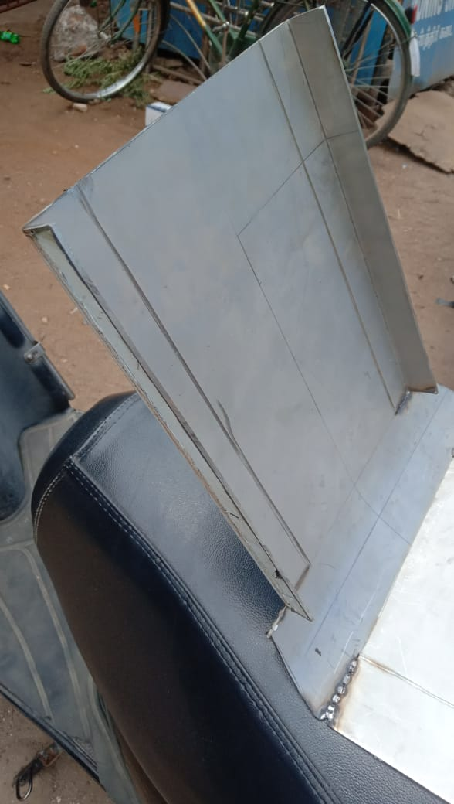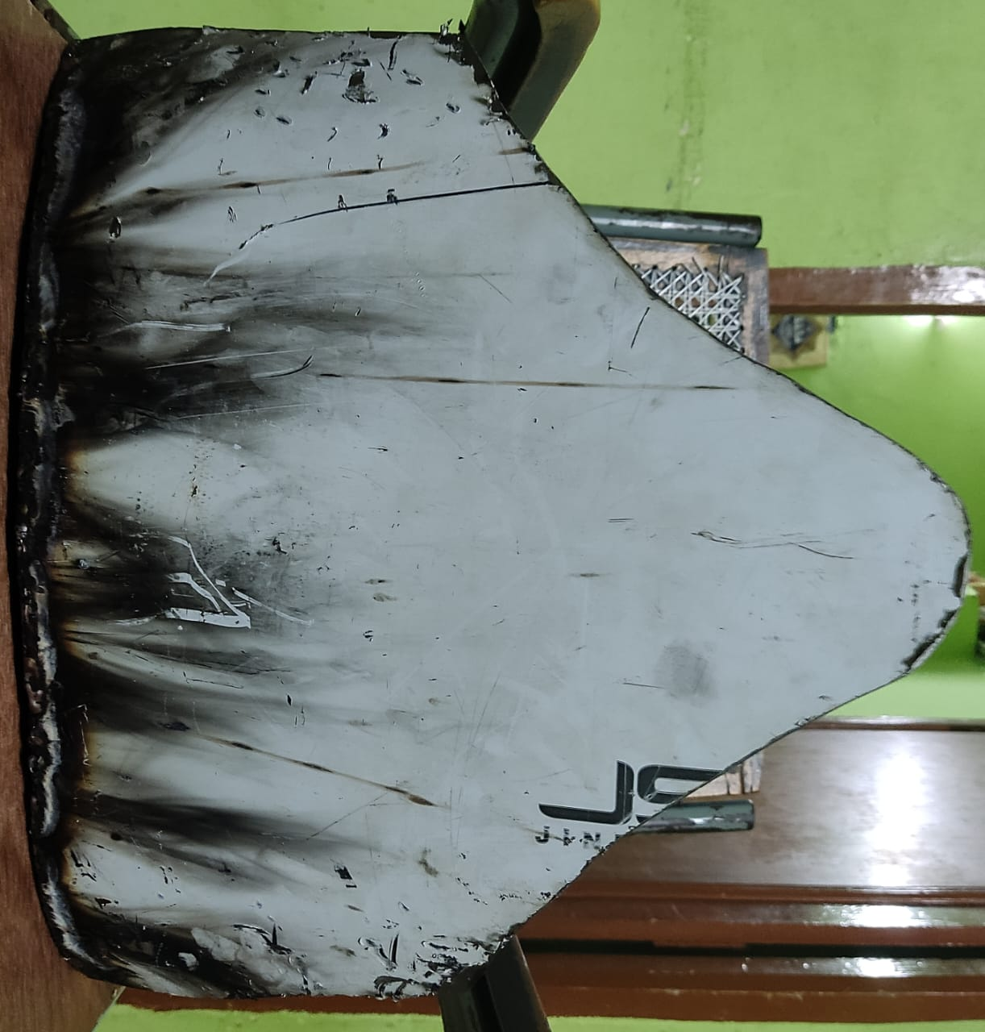 - 5**

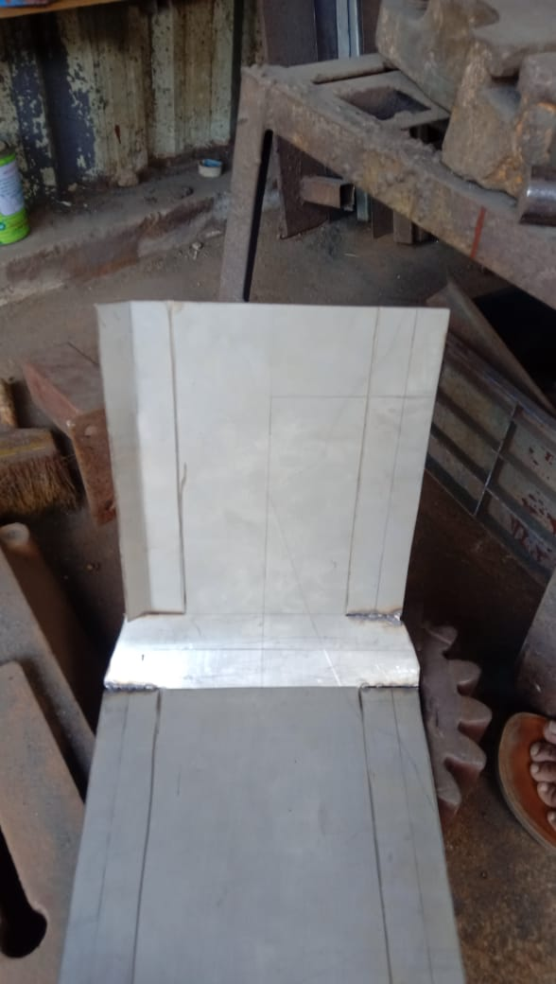

**FIGURE NO - 6**

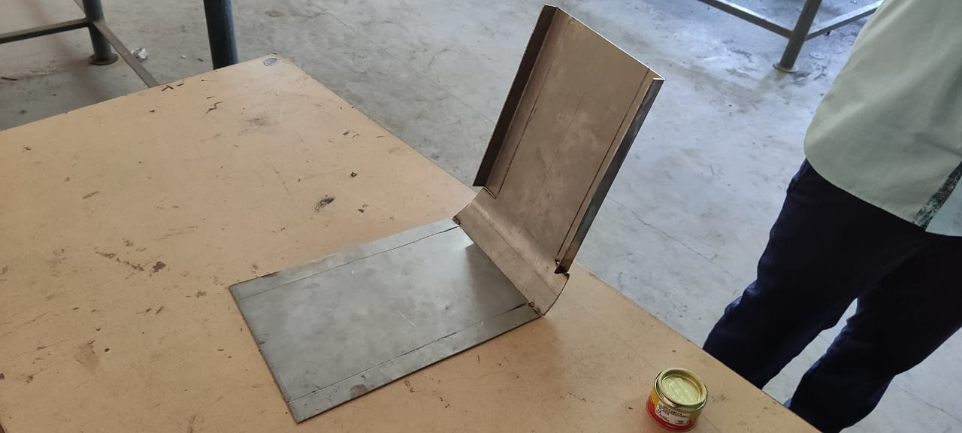

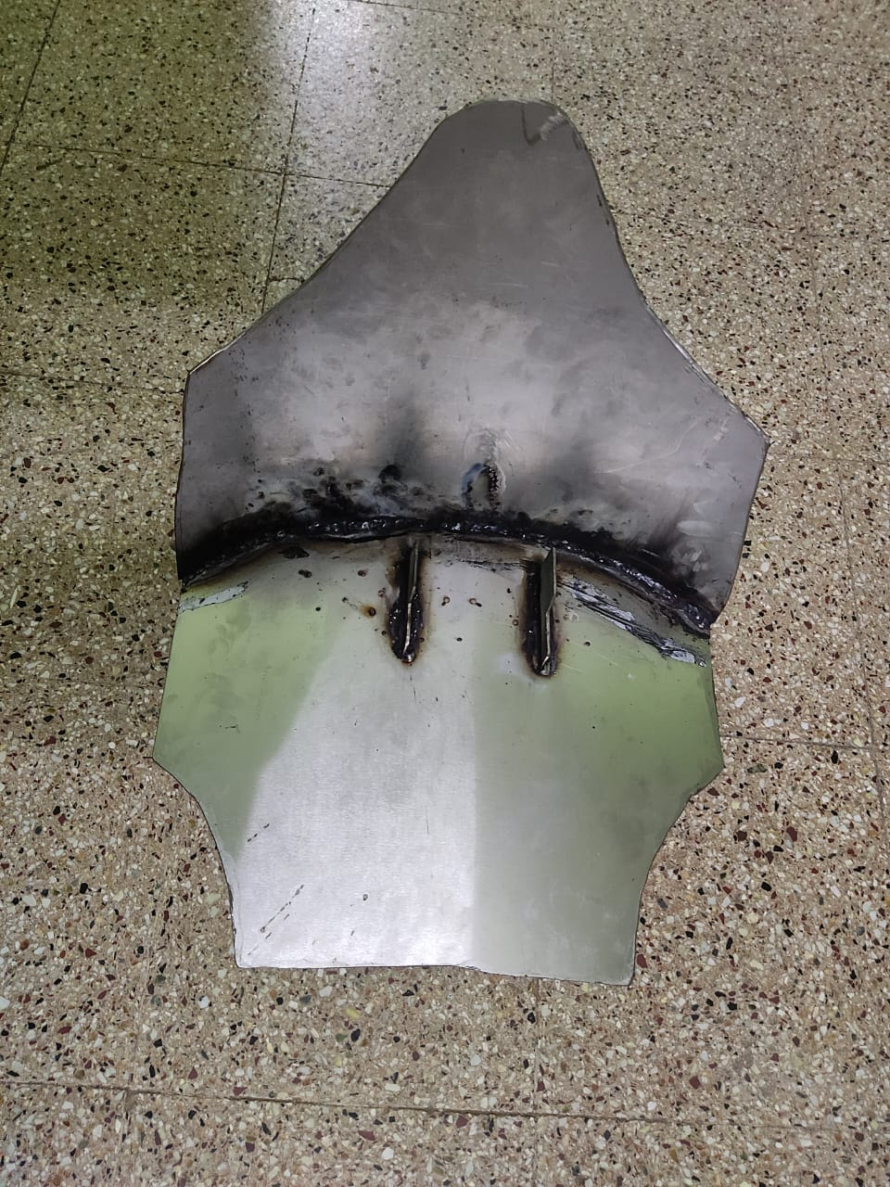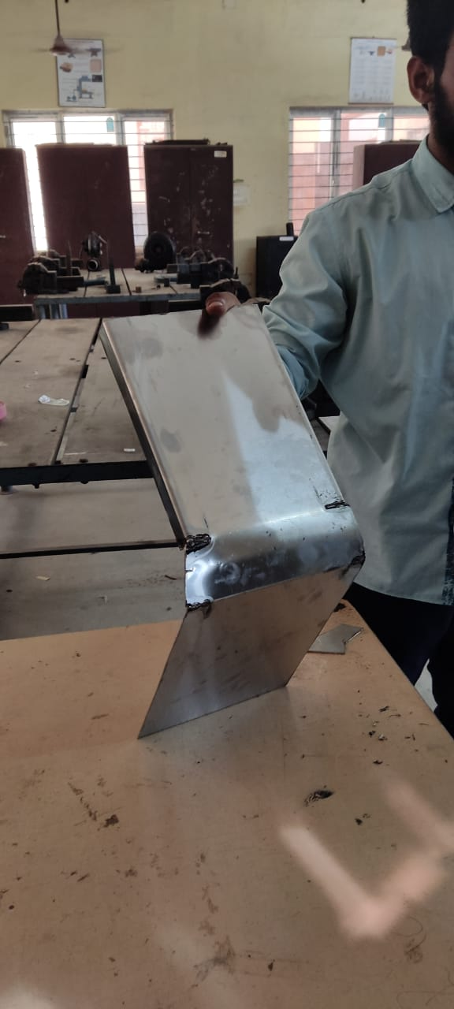

# Sheet metal cutting with angle grinder

The angle grinde can cut both soft and hard metals with an angle grinder by using abrasive cut-off discs. You will need different types of cutting wheels for ferrous (steel) and nonferrous metals (aluminum, copper, brass, etc.). Due to its handheld design and disc size, angle grinders are usually limited to a maximum of 2 ¾ inches (70mm) deep cuts.

Stainless Steel

The temperature generated during cutting is an important factor to consider with stainless steel since it can become heat distorted easily.Zirconia alumina is useful for heavier duty projects as it proves to be a highly durable disc with a long-lasting lifespan.

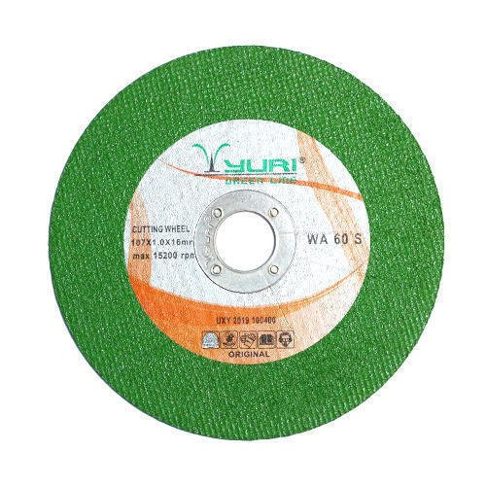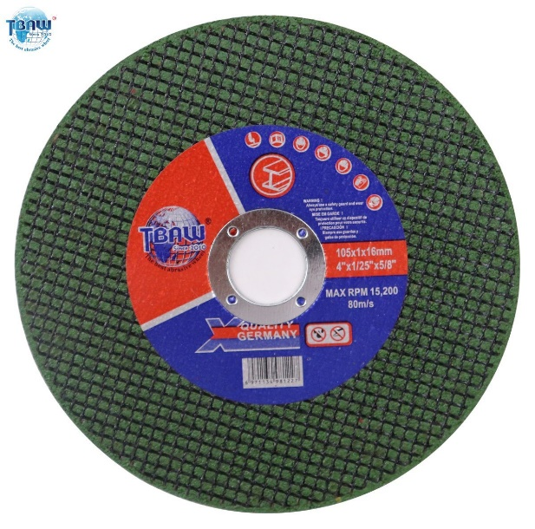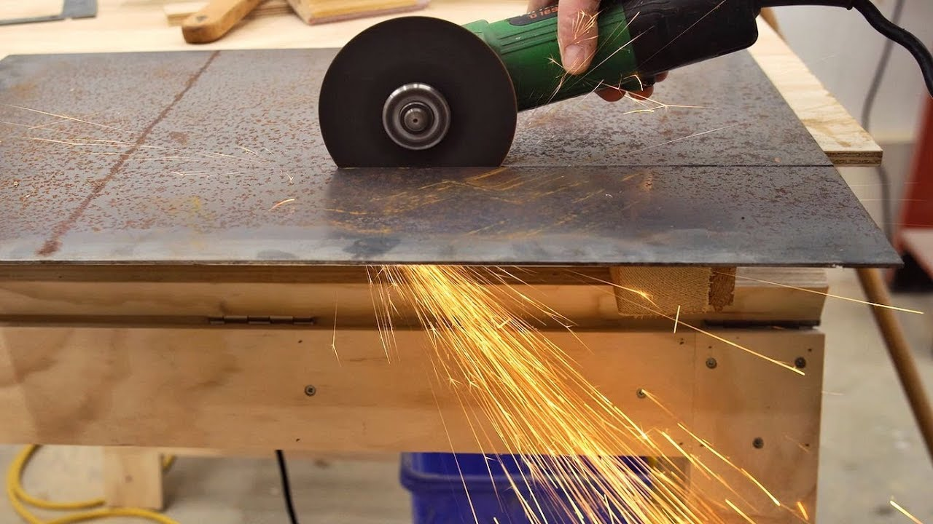

# Sheet metal grinding process with angle grinder

Grinding is the process of removing metal by the application of abrasives which are bonded to form a rotating wheel*.* When the moving abrasive particles contact the workpiece, they act as tiny cutting tools, each particle cutting a tiny chip from the workpiece. It is a common error to believe that grinding abrasive wheels remove material by a rubbing action; actually, the process is as much a cutting action as drilling, milling, and lathe turning.

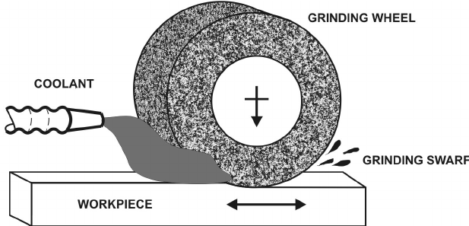

arc welding process

Arc welding is a type of welding process using an electric arc to create heat to melt and join metals. A power supply creates an electric arc between a consumable or non-consumable electrode and the base material using either direct (DC) or alternating (AC) currents.

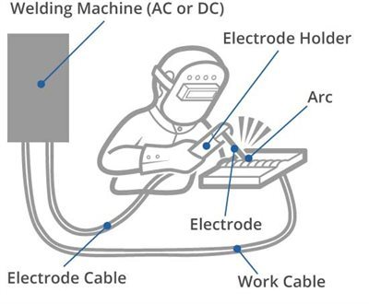

# **TYPES OF WELDING.**

* **MIG** – Gas Metal Arc Welding **(GMAW)**
* **TIG** – Gas Tungsten Arc Welding **(GTAW)**
* **Stick** – Shielded Metal Arc Welding **(SMAW)**
* **Flux-cored** – Flux-cored Arc Welding **(FCAW)**

# Sheet metal welding process with arc welding (MIG)

MIG welding, or gas metal arc welding as it is more formally known, is one of the more popular ways to weld stainless steel. There are many similarities between MIG welding stainless steel and welding carbon steel. No special drive rolls need to be used, and the electrical polarity remains the same. However, shielding gas compositions are typically different. Lower amounts of oxygen are allowable when welding stainless steel, so O2 or CO2 levels should be kept around 2% or lower. It is quite common for tri-blend shielding gases that contain argon, helium, and carbon dioxide or oxygen to be used when MIG welding stainless steel. Since corrosion resistance will typically be desired in the weld as well as the base material, stainless steel welding wire must be used. Furthermore, to prevent cracking, the filler wire and base stainless steel should be a low carbon version or have stabilizers in them such as tantalum or niobium. Using a pulsed welding waveform can also help users MIG weld stainless steel 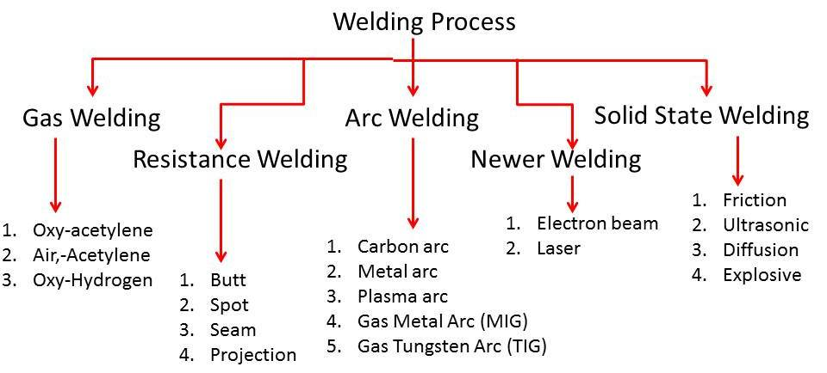more successfully.

# 

kind of bikes need skid plates:

Skid plates are considered an important component of most vehicles. But they are absolutely essential for bikes built with a lowered height as well as vehicles developed for off-road usage. The reason is simple. Due to having a close distance between the road and their base framework, lowered vehicles are most likely to hit the road during a drive. This risk also applies to offroad vehicles, which can receive unwanted abrasions from their journey on uneven ground. But given that any type of car can run into unexpected road conditions, it is best to have your vehicle protected by skid plates. How well do skid plates work for each category depends upon the material and the build of these plates. The protection of skid plates is so profound that modern bikes. it a point to include skid plates in their factory-assembled models.This goes on to show that skid plates are not just meant for lowered vehicles or off-road automobiles, but they are also effective in protecting everyday cars from harm.need a dirt bike skid plate when riding in the woods or around rocks. A skid plate protects your dirt bike efficiently from rocks, logs and other flying debris.

**COST ESTIMATION:**

* Stainless sheet metal :3500
* Welding cost :250
* Bending:350
* Painting :250
* Labour charge :200
* Report cost:200

**ADVANTAGES:**

* Increased resistance against any impact or debris found on the road.
* It covers the front compartment of the car, so the engine is more protected against dust and dirt.
* Longer lifespan compared to skid plates made of plastic or fibre glass.
* It protects the frame, motor and linkage on an off-road motorcycle.

**DISADVANTAGES:**

* The material is much heavier compare to aluminium

Cost is higher than normal sheet metal.

Conclusion:

* SKID PLATE protects the vechile from the damage of the engine.
* It also prevent the the silencer and engine in rainy days from the staganent water.
* This skid plate is made up of stainless steel and it also can be done in aluminium sheet.
* Aluminium is costly than the stainless steel sheet metal